IPC Class 2 VS Class 3: The Different Design Rules
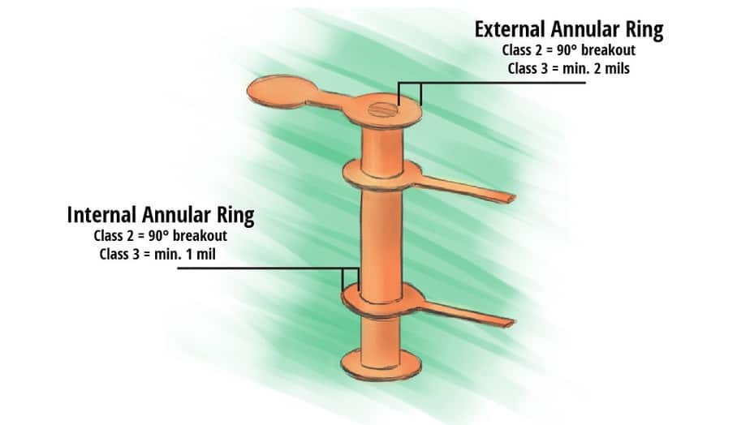

As a circuit board manufacturer, designers often ask us about the difference between IPC Class 2 and Class 3. Class 1 does exist although we rarely produce boards that fall into this classification. Most of the times, even if the end-use of the product only requires Class 1. We will make it Class 2 just to ensure a better performance. This article will help you understand the different design rules for IPC Class 2 and Class 3 circuit boards.
There are four IPC classifications. Class 1 is assigned to general electric boards with a limited life and a “simple” function, such as the ones you can find in remote controls. Class 2 is for dedicated service electronic products. This means that you expect the board to have an extended life so you can place it in a television, a computer, or an air conditioner. Class 3 PCBs are tighter in tolerances as opposed to Class 1 and Class 2 boards. John Perry, Director of Printed Board Standards and Technology at IPC, explained:
“Class 3 includes products where continued high performance or performance-on-demand is critical, product downtime cannot be tolerated, end-use environment may be uncommonly harsh, and the product must function when required.”
These circuit boards are highly reliable. They are used to achieve high performances in the military or in medical, for instance. IPC-6012DS Class 3A includes space and military avionics. It is the highest class for printed circuit boards.

Inspection and acceptance criteria
After the end-use of the product, the degree of inspection is what you should take into account when choosing which classification your PCB should fall into. Keep in mind that inspection is one of the factors that drive up the cost when an assembly goes from Class 2 to Class 3.
When you think about it, PCBA (Printed Circuit Board Assembly) is not a simple task. The board needs to properly function once assembled with all its components, materials, and the solder to hold them together. Depending on which class your board falls into, the requirements you will have to meet for inspection will differ. This is when some IPC documents come in handy to set the level of acceptance criteria for each class of products.

Documentation
On Circuitnet, Leo Lambert, Vice President of EPTAC, made a list of the most significant documents, which are “the IPC 2220 series for circuit board design and fabrication, the IPC 6010 series documents for board performance and quality, IPC-A 600 for board Acceptability requirements, J-STD-001 for soldering requirements and IPC-A-610 for Acceptability requirements.”
There is a misconception that links Class 3 boards only to the aerospace field. It is often true but Class 3 is not exclusive to aerospace or any other industry. The criteria for the four IPC classes are based upon the application of the product. Therefore, Class 3 can also be the criteria for avionics, military, industrial, and medical applications.
It makes sense that a lot of Class 3 boards are for aerospace. The products launched into space have to be highly reliable to prevent any failure that could be critical. And the additional inspection is just too pricey for the commercial and consumer market.
When you require a Class 3 circuit board, it implies that the product has to be built according to the complete IPC criteria. This means that the design and manufacture teams must take into account laminate selection, plating thickness, annular ring requirements, manufacturing processes, material qualifications, facilities arrangements, inspection criteria, etc. in order to produce the board that meets all the Class 3 requirements.

The differences between Class 2 and Class 3 for assembly
Umut Tosun, Application Technology Manager at Zestron America, explained, “The major differences between Class 2 and Class 3 are found in component placement for surface-mount components, cleanliness requirements based on residual contaminants on the assemblies, plating thicknesses as defined in plating through-hole and on the surface of PCBs.”
During assembly, surface-mount components might be slightly placed off pad. This is what we call a visual defect since it does not usually affect the electrical and mechanical performance. It, therefore, does not matter for Class 2 circuit boards. However, Class 3 does not accept any imperfection and this type of assembly misstep will cause the circuit board to fail the inspection.
The amount of barrel fill required for through-hole leads is 50% for Class 2 and 75% for Class 3. As it can be delicate to get the paste into small plated through-holes (PTH), The advice is to design your PTH 15 mils over the diameter of the lead. This way, you will have 7.5 mils on each side, which will make it easier for the paste to fill the barrel.
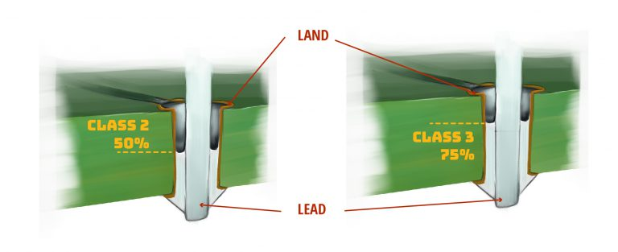

The differences between Class 2 and Class 3 for PCB manufacturing

Annular ring and drill breakout
Another topic Class 2 and Class 3 differ on is drill breakouts. Class 2 allows breakouts from the annular ring whereas Class 3 does not accept any lifted or fractured annular rings. Class 3 boards need to be highly reliable and when there is a breakout, it is too difficult to find out how much is really broken out and how much it really affects the connection with the pad. For Class 2, 90 degrees breakout of the hole from land is allowed provided minimum lateral spacing is maintained.
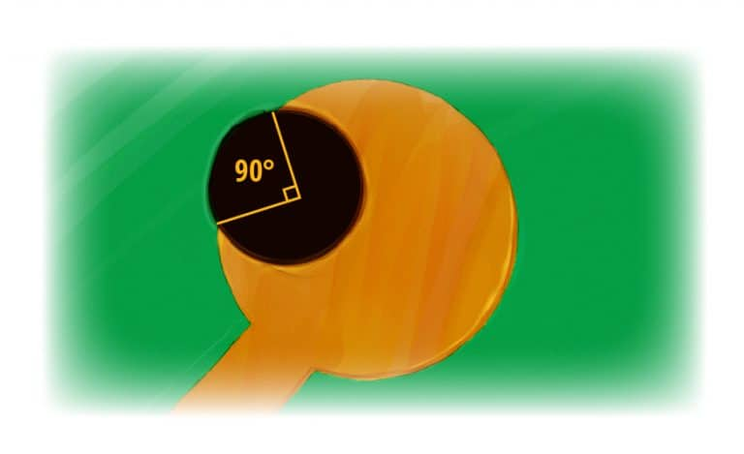
The conductor junction cannot be reduced more than 20% of the minimum conductor width specified on the engineering drawing. The conductor junction should never be less than 2 mils or the minimum line width, whichever is smaller. For Class 3, the minimum internal annular ring cannot be less than 1 mil. The external annular ring cannot be less than 2 mils. It is measured from the inside of the PTH barrel to the edge of the land pad and may have 20% reduction of the minimum annular ring in isolated areas due to defects, like pits, nicks, pinholes, or dents.
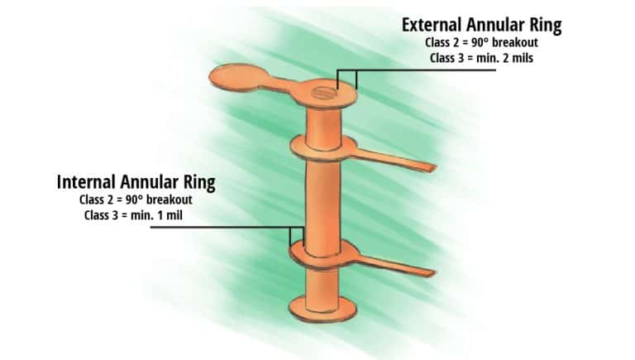
There will be a difference between the designed annular ring and the manufactured / actual annular ring. This is due to shifting in materials during the circuit board manufacturing process. To meet the Class 3 requirements, We uses Pluritec machines to discover the shift in material, software to re-scale the drill locations, and vision drilling to accurately place the drills.

Design rules for annular rings
To achieve acceptance for Class 2 and Class 3, follow the tables below published by Altium. The first one gives the annular ring requirements for mechanically drilled blind, buried, and through holes on ½ oz copper:
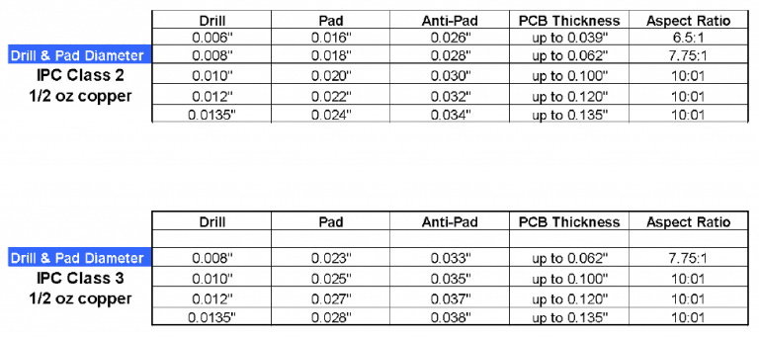
And this table is for various copper thicknesses:
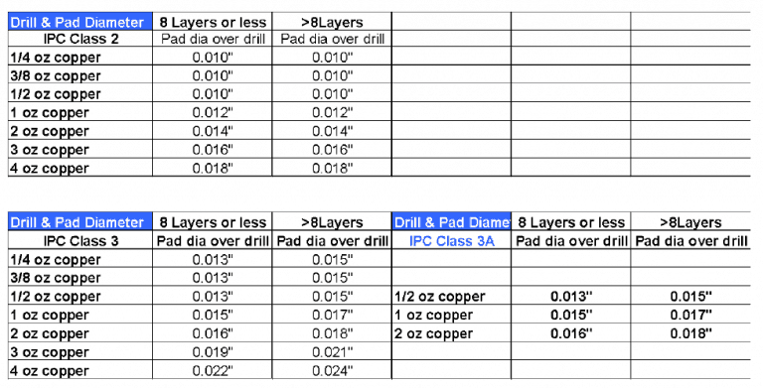

PCB dielectric requirement
The minimum dielectric for Class 2 and Class 3 is 3.5 mils.
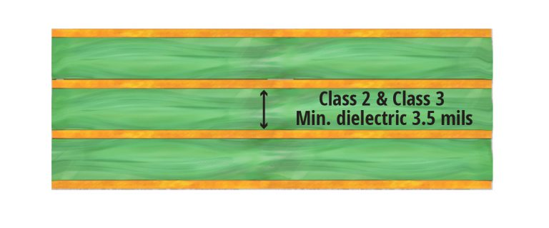

PCB through-hole plating requirement
Class 3 requirements are as well more astringent for voids in copper. On Circuitnet, Paul Reid, Program Coordinator at PWB Interconnect Solutions, said, “A copper void is where the copper plating in the barrel of the hole is missing exposing the dielectric material of the drilled hole. Class 2 allows one void in 5% of the holes. Class 3 and 3/A allows no voids.” The plating thickness requirement for Class 2 is 0.8 mil as opposed to 1 mil for Class 3.
These are just a few requirements that differ between Class 2 and Class 3. As usual, the best advice we can give you is to communicate with your PCB manufacturer. They will guide you and help you get it right the first time. You should also request a cross-section of your board to make sure that your shop met your Class 2 or Class 3 requirements.

PCB cross-section to verify the spec requirement
Visual and X-ray inspections are not always enough to ensure the integrity of a board. To make sure that your PCB manufacturer met your requirements, ask for a cross-section analysis. This destructive technique is the best way to verify your PCB internal structure, mostly using a microscope. The test can check for various aspects, such as cracks, voids in solder joints, through-hole filling, etc.
Below is a cross-section of a Class 2 circuit board:
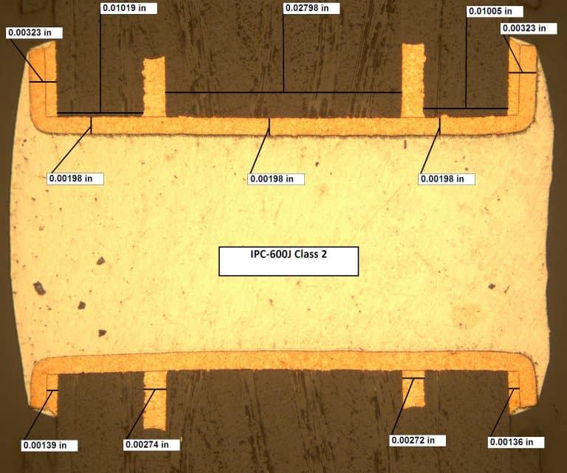
And this is a cross-section of a Class 3A board:
